Article

Energy Meter Patch Resistance and Welding Spot Anomaly Detection Analysis System Based on Machine Vision

Chao Jiang *, ShengZe Chen , ZhiJing Zhang, and Rui Li

State Grid Shanghai Electric Power Company Marketing Service Center , Shanghai 200051, China;

**\*** Correspondence: 107633120@qq.com; Tel.:+86-137-9545-8737

**Abstract:** Based on the problems such as the difficulty of detecting and obtaining evidence of patch resistance replacement and welding spot anomaly in the current field of meter anomaly detection, and the inconvenience of the detection device, a patch resistance and welding spot anomaly detection algorithm is proposed based on machine vision, and a set of meter anomaly detection field analysis system is developed and realized. The resistance anomaly detection algorithm firstly combines the K-D tree and Ransac to complete the high-efficiency energy meter registration, then detects the suspected resistance abnormal area through the difference shadow method, and then judges the resistance abnormal situation according to the resistance value recognized by the classification network; the welding spot anomaly detection algorithm enhances the feature of the image through the saliency detection, then obtains the target information of the welding spot by segmentation, and finally determines the welding spot abnormal condition in combination with the connection domain analysis. Experimental results show that the precision of patch resistance anomaly of this system reaches 95.28%, and the detection time is about 1.52s; the precision of welding spot anomaly reaches 96.74%, and the detection time is about 0.74s. The system can meet the requirements of spot detection accuracy and speed, and has good application value.

|  |
| --- |
| **Citation:** Jiang, C.; ShengZe, C.; ZhiJing, Z.; Rui, L. Energy Meter Patch Resistance and Welding Spot Anomaly Detection Analysis System Based on Machine Vision. *Information* **2022**, *13*, x. https://doi.org/10.3390/xxxxx  Academic Editor: Firstname Lastname  Received: date  Accepted: date  Published: date  **Publisher’s Note:** Machine Vision-Based Energy Meter Patch Resistance and Welding Spot Anomaly Detection Analysis System.    **Copyright:** © 2022 by the authors. Submitted for possible open access publication under the terms and conditions of the Creative Commons Attribution (CC BY) license (https://creativecommons.org/licenses/by/4.0/). |

**Keywords:** electric energy meter; anomaly detection; template matching; saliency detection

1. Introduction

At present, power supply enterprises often compare the power consumption data manually, and then preliminary determine whether the user is suspected of stealing electricity according to the seal of the power meter. Due to the simplicity and roughness of past acts of stealing electricity and the visibility of the naked eye, on-site detection is convenient. However, the technology of stealing electricity is constantly developing. At present, there is a way to reduce the amount of electricity actually recorded by the electric energy meter by replacing the welding spots of the patch resistance and short-circuit current input area. At the same time, due to the high conceal ability of these two abnormal ways, it is difficult to discover and obtain evidence by manual visual inspection [1-2]. Domestic and foreign scholars have studied a lot of detection equipment based on image processing, machine vision and other technologies, and have also achieved some practical results [3-8]. By studying the basic algorithm of template matching and using the feature blocks of pre-marked images, the authors of [9] improved the basic template matching algorithm; The authors of [10] designed an electric energy meter appearance defect detection system based on machine vision; The authors of [11] designed a smart electric energy meter printed circuit panel consistency detection system based on deep learning technology, which replaced the manual detection mode and was applied in the laboratory testing work; The authors of [12] adopted the method of deep learning to detect PCB patch elements, but it had strict requirements on sample data and computing power, and the required computing power cost was high, operation power consumption was large, which could not be popularized in the on-site environment.

In order to solve the above problems, the anomaly detection algorithm combines the classic image processing technology with the deep learning technology driven by big data, and completes the patch resistance anomaly detection algorithm and welding spot anomaly detection algorithm. Meanwhile, a set of on-site detection and analysis system of electric energy meter anomaly has been developed. Compared with other existing systems, it has the advantages of low power consumption, low cost and friendly interaction in the use of the on-site environment, and has a supporting role in theft and forensic work, and has good application value.

2. Algorithm Design

2.1. Data set production

The meter PCB data set is the basis for detecting resistance and welding spot anomaly. Whether it is a traditional image visualization method or a deep learning method, high-quality image datasets are indispensable. As a typical data-driven method, deep learning requires high-quality and sufficient samples to train the model to obtain optimal network weight parameters. The anomaly detection algorithm proposed in this paper also has a large number of key parameters that need to be set manually, which affects the quality of the algorithm to a certain extent. Therefore, the algorithm is also data-driven when designing the algorithm, and the optimal parameters are selected through the verification of a large number of datasets to enhance the generalization ability of the algorithm in this paper. A total of 1000 PCB raw data sets were used in the experiment, as shown in Figure 1.

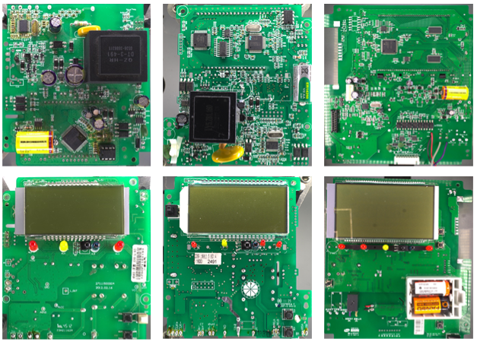

**Figure 1.** Meter data set

Of these, 600 are experimental energy meter samples, which are provided by Shanghai Electric Power Company's Power Science Research Institute; image datasets obtained only through existing energy meter samples cannot meet the needs of algorithm design, so PCB image collection was carried out in the experiment, and another 400 samples are collected for different types, different sizes, and different uses of patch element circuit boards. Through the designed meter anomaly analysis device, the PCB image fixed in the support area is acquired, and the meter data set is obtained after rotation, cropping and brightness conversion.

2.2. Bond resistance anomaly detection

The anomaly detection system with adjustable light source and single vision firstly matches the electric energy meter with the registration algorithm, then screens the abnormal area, and then detects the patch resistance anomaly in this area through the traditional image processing technology. The template image and the sampling detection image of the electric energy meter of the system are both captured by the built-in camera of the anomaly detection device, but the captured image is affected by lighting, angle, thermal noise and other factors. Therefore, there is a certain difference in the captured image each time under the same sensor. Therefore, the registration of the sampling map and the template map is the first step in the detection of resistive anomaly.

In the production of electric energy meters, there are minor deviations in the position of components, inconsistent appearance and shape of welding spots, defects in printed characters, etc., so that the similarity between the detection image and the template image is low in many details. Currently, characteristic point registration methods with good results include FREAK, SURB, OBR, etc. [13-15], but the results are very poor in the application scenario of this study. For the detection of such high complexity anomaly, the characteristic point registration method sift with good stability, rotational invariance and high texture information utilization is selected. The original sift registration algorithm has a good size change robustness and a large number of feature points in this application scenario, as confirmed by a large number of experiments in the early stage, the effect is shown in Figure 2.

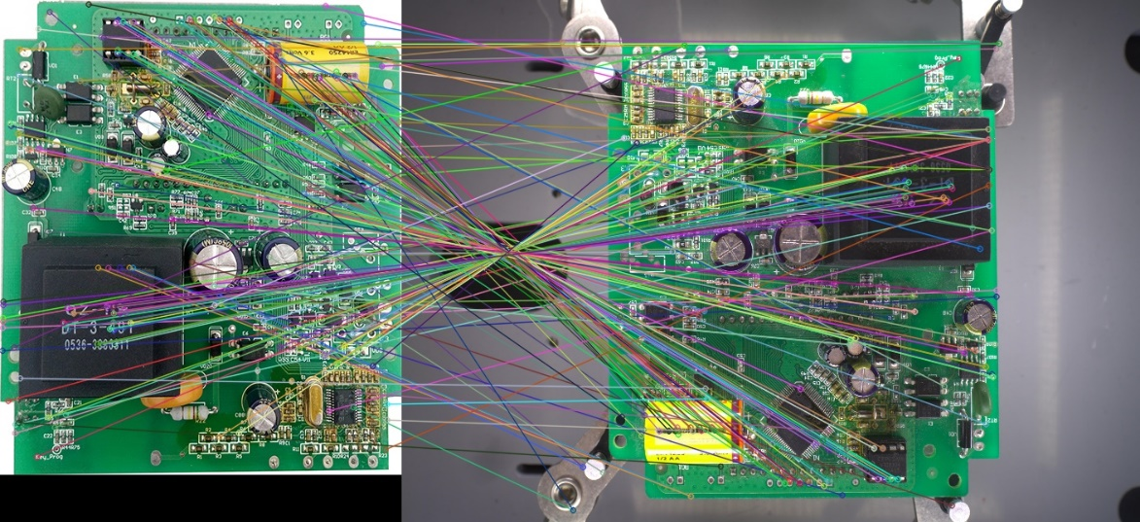

**Figure 2.** Raw sift registration results

Considering the limited test terminal hardware computing performance and the need to ensure the high accuracy of the test results, the registration algorithm combines the K-D tree with Ransac, and screens the effective feature points for matching, which greatly improves the registration speed and accuracy. The effect is shown in Figure 2. Assuming that each feature point corresponds to a 128-dimensional feature vector, there are *i* feature vectors in the template diagram, and the corresponding set *A = {a1,a2, …, ai}*; *j* feature vectors in the detection diagram, and the corresponding set *B = {b1,b2, …,b j*}, the specific operations are as follows:

(1) Set A is used as the input, and a K-D tree is established for the *i* 128-dimensional vectors. Each feature vector in Set *B* is searched for in Set *A* for the minimum feature vector of the European style. The European style distance expression is as follows:

|  |  |
| --- | --- |
|  | (1) |

(2) Select the feature vector in the detection diagram and the feature vector in the template diagram having the minimum European distance, and generate a matching pair with the corresponding feature vector in the template diagram. The corresponding set *P* = {*p1, p2, …, pk*}, the matching pair pk contains a detection diagram feature vector *p*k1 and a template diagram feature vector *p*k2.

(3) In order to ensure the registration accuracy, set the feature vector angle difference threshold V = | *p*k1(*θ*) - *p*k2(*θ*) |, where *θ* is the main direction angle, exclude the matching pair with *V* > 50 ˚, and then sort the retained matching pair according to the Euclidean distance.

(4) Establish a perspective transformation model, and the expression equation is as follows:

|  |  |
| --- | --- |
|  | (2) |

Where (*x, y*) and (*x’, y’*) are the coordinate positions of the matching pairs *p*k1 and *p*k2, respectively, and M is a model transformation matrix.

(5) The matching pair obtained in Step (3) is set as a candidate set, and 4 matching pairs are randomly selected to solve the new matrix *M* in place of the perspective transformation model.

(6) Traverse the remaining unextracted matching pairs in the candidate set, calculate the coordinate position of the feature vector in the template diagram by substituting a new matrix *M*, set the internal point set *C* and the error tolerance threshold *t*, and if *t* < 10, classify the current matching pairs as the internal point set.

(7) According to the test results on the data set, select the proportional threshold *β* = *0.8*. Steps (5) and (6) until the ratio of the number of samples of the inner point set to the number of samples of the candidate set matches is greater than *β*, select the matrix *M* corresponding to the final number of iterations as the better result model, and finally use the model to complete the registration of the electric energy meter through perspective transformation. The matching results are shown in Figure. 3.

|  |  |  |
| --- | --- | --- |
|  | | |
| (**a**) | | |
|  |
| (**b**) |

**Figure 3.** Matching method in this paper. (a) forward matching. (b) reverse matching.

The size of the to-be-tested diagram after registration is large, and it takes a long time to directly detect the anomaly. In order to further improve the operating efficiency of the system, the detection algorithm presets the key detection area of the template map in advance according to the circuit principle and prior experience, and usually selects the resistive dense zone as the currently matched key area. At the same time, the resistive information in the key area is labeled, so that it is not necessary to directly obtain the template prior information during on-site detection, so that the algorithm can more specifically complete the rapid detection task. The number of key areas varies greatly from meter to meter, as shown in the box in Figure. 4.

|  |
| --- |
|  |

**Figure 4.** Image to be tested

A similarity metric is used to measure the similarity between the template and the image to be matched to achieve the matching of key areas. The operation is as follows:

(1) Set the key area of template diagram T, and find the corresponding position in the inspection diagram I.

(2) Complete the matching of the key areas of the template diagram and the detection diagram according to the square difference matching method, normalize the matching results, and then calculate the minimum value in the detection matrix. The smaller the value, the more similar the matching results are. The matching results are shown in Figure. 5.

|  |  |
| --- | --- |
|  | (3) |

(3) Record the optimal position coordinates of key areas in the inspection diagram.

|  |  |
| --- | --- |
|  |  |
| (**a**) | (**b**) |

**Figure 5.** Key area matching results. **(a)** template diagram. **(b)** detection diagram

Resistance anomaly is divided into two categories, one is the absence of resistance and the other is the replacement of resistance. The resistive anomaly detection process first needs to use the color value feature extraction technique to map the image of key areas of the detection image to the HSV color space to complete the initial background segmentation, and then complete the detection of suspected resistive abnormal areas in combination with the difference imaging method. The effect is shown in Figure 6.



**Figure 6.** Resistance uspected Abnormal Area Detection Results

Then, a deep learning method is further applied to the region, and the resistance character values of the template diagram and the detection diagram are compared to determine the exception type.

Traditional OCR recognition techniques target single-character recognition, whereas resistance characters are usually composed of multiple characters and require further processing. The method of segmenting the resistance value character based on the characteristics of the connection area can effectively solve the problem of character tilt and complex background. According to the needs of the accuracy of the recognition of actual application scenarios and the limitation of the computing power of deployed devices, the resistance character recognition adopts the lightweight convolutional network ShuffleNetV2 [16]. The patch resistance data set selected 9 alphabets and 12 numeric characters in the numeric alphabet mixed standard method. Each character contains about 100 samples of different angles, lighting and meter models from different sources; the specific operations are as follows:

(1) Separate the abnormally suspicious resistance from the complex background, and extract the connection area within the threshold range by morphological operation of the patch resistance as a character.

(2) Rotate the resistive image by 90 degrees with an aspect ratio of less than 0.8.

(3) Using the characters of the lightweight convolutional network ShuffleNetV2 to classify different kinds of resistance values, and then stitching the single character classification results to complete the character recognition of the resistance value of the patch, the recognition results are shown in Figure 7.

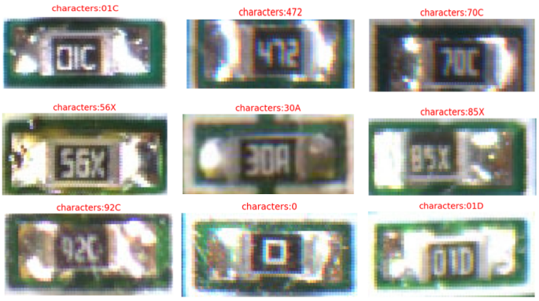

**Figure 7.** Resistance value recognition result of patch

Table 1 The registration results show that the original sift components are mostly rectangular, the edges are not smooth, and there are many feature points to be detected. The registration screening algorithm in the script can greatly reduce the number of feature points of template diagrams and sampling measurement diagrams, shorten the registration operation time of the electric energy meter, and meet the actual registration needs; Table 2 The character recognition results show that the method adopted in the script has good performance in the identification of resistance characters, and there are a small number of missed and erroneous detection cases for the resistance at the edge position of key areas;

**Table 1** Comparison of registration results

|  |  |  |  |  |
| --- | --- | --- | --- | --- |
| **Registration Method** | **Template Graphic**  **Number of collection points** | **Detect Tuttle**  **Number of collection points** | **Correct Match**  **Pairing number** | **Registration time** |
| Original SIFT | 2074 | 3097 | 1456 | 5.72s |
| The proposed method | 97 | 122 | 84 | 1.32s |

**Table 2** Character recognition results

|  |  |  |  |  |
| --- | --- | --- | --- | --- |
|  | **Number of Samples** | **Number of errors** | **Precision** | **Total Time Spent** |
| Resistance segmentation | 425 | 12 | 97.17**%** | 0.06**s** |
| Resistance Value Identification | 312 | 14 | 95.55**%** | 0.08**s** |

Meanwhile, in order to verify the validity of the anomaly detection algorithm in this paper, the following indicators are selected: the correct inspection rate (P), the recall rate (R) and F1. The calculation formula is as follows.

|  |  |
| --- | --- |
|  | (4) |
|  | (5) |
|  | (6) |



**Figure 7.** Resistance value recognition result of patch

**Table 3** Resistance anomaly detection results

|  |  |  |  |  |
| --- | --- | --- | --- | --- |
|  | **Precision** | **Recall** | **F1** | **Total Time Spent** |
| Resistance anomaly | 95.28**%** | 96.04 | 95.65% | 1.52s |

It can be seen from Table 1, Table 2 and Table 3 of the comprehensive table that the length of registration in the process of resistance anomaly detection is a large ratio, and the normal inspection rate and real-time can meet the actual needs of the site.

2.3. Detection of anomaly in welding spots

Among the meter anomaly, a common means is to short-cut the welding spots of the current input area, as shown in Figure 8.

|  |  |
| --- | --- |
|  |  |
| **(a)** | **(b)** |

**Figure 8.** Electric energy meter welding spot diagram. **(a)** abnormal welding spot short junction diagram. **(b)** normal welding spot template diagram.

The authors of [17] used traditional machine vision methods to detect welding spot defects, but had the disadvantages of difficult threshold selection and poor robustness. The authors of [18] proposed a deep learning welding spot detection method to classify leakage welding, bridging, and normal welding spot images, but it could not meet the requirements of on-site real-time detection.

A fast welding spot anomaly detection algorithm based on saliency detection and connectivity domain analysis is proposed for the above problem. The detection steps are as follows:

(1) Convert the image to be detected into lab color space, and calculate the average *Lμ, Aμ, and Bμ* on the *L*, *A*, and *B* channels.

(2) Saliency images are obtained by saliency detection. The average value in the images usually characterizes the background information. By calculating the square weight of the difference between each channel of Lab and its average value, the background can be weakened by highlighting the target, and the purpose of detecting saliency areas is achieved. saliency values of single-channel saliency images were calculated according to the following formula.

|  |  |
| --- | --- |
|  | (7) |
|  | (8) |
|  | (9) |
|  | (10) |

Where S is a saliency image of a single channel, *x* and *y* are coordinates of pixel points, and *α*, *β* and *γ* are hyperparameters. After verification of a large number of energy meter soldering joint picture sets, when the values are 0.5, 0.8 and 0.1, respectively, better segmentation results can be obtained in step (3).

(3) Binary processing of the obtained saliency image, binaryization using the maximum class-to-class variance method according to the characteristics of the saliency image can achieve a better segmentation effect, then use the opening operation in morphological processing to remove noise and interference lines, and keep the pixel dot cluster of the target welding spot.

(4) Calculate the connection domains *U*1, *U*2, *U*3, *U*4, *U*5…, *U*m of all welding spot targets in the split image of the welding spot to be tested; calculate the connection domains *V1, V2, V3, V4, V5, …, Vn* of the real welding spot targets according to the template images pre-described. Traversing each connection domain *Ui**(*i∈m), calculate the intersection ratio IOU(*i,j*) with all real welding spot connection domains *V*j *(j* = 1,2, *…,n*), and the calculation formula is as follows:

|  |  |
| --- | --- |
|  | (11) |

(5) All calculations are ordered quickly to yield n IOU(*i,j*). If the maximum value max(IOU(*i,j*))∈(0.8,1) indicates that there is a real welding spot *V*j on the template and a welding spot *Ui* on the image to be tested roughly coincide, it can be determined that *Ui* is a normal welding spot; if the maximum value max(IOU(*i,j*))∈(0.1,0.8) indicates that there is a partial coincidence between the real welding spot *V*j on the template and the welding spot *Ui* on the image to be tested, but there is a large difference, it can be determined that there is an anomaly in the welding spot bridging, and *V*j is marked as having been matched; if the maximum value max(IOU(*i,j*))∈[0,0.1] indicates that there is no real welding spot *Vj* on the template and the welding spot *Ui* on the image to be tested, it can be determined that there is a new anomaly in the welding spot; if there are remaining unmarked welding spots *Vj* on the template image, it can be determined that there is an anomaly in the welding spot. The process diagram of welding spot anomaly detection algorithm is shown in Figure 9.

The anomaly detection performance results of welding spots are shown in Table 4. The anomaly types of welding spots are determined by combining the significance inspection and the connection domain. The detection accuracy is high, which can meet the needs of real-time detection.

|  |  |
| --- | --- |
|  |  |
| **(a)** | (**b**) |
|  |  |
| **(c)** | **(d)** |

**Figure 9.** Process diagram of welding spot anomaly detection. **(a)** Saliency diagram. **(b)** Binary diagram. **(c)** Filter diagram. **(d)** Detection result diagram.

**Table 4** Test results of welding spots

|  |  |  |  |  |
| --- | --- | --- | --- | --- |
|  | **Precious** | **Recall Rate** | **F1** | **Total Time Spent** |
| welding spot anomaly | 96.74**%** | 96.85**%** | 96.79**%** | 0.74**s** |

3. System design and implementation

3.1. Hardware system design

A portable meter anomaly detection and analysis system was designed to complete the on-site meter anomaly analysis by establishing the meter parameter recognition database and standard image comparison database, and to assist in the anti-theft electric troubleshooting and evidence presentation.

The device is in the form of a portable suitcase, which is easy to move and carry. It has a built-in tablet computer, 2000W pixel high-definition camera, RFID data reader, high-precision multimeter and other devices. The main hardware of the system includes:

(1) Tablet: Support 5G, Wi-Fi and other communication methods to achieve data query and sample alignment functions.

(2)HD camera: with industrial-grade light source, supports multi-angle shooting, 20 million pixels.

(3) RFID data reader: realizes the reading of the energy meter information, and facilitates the query of the energy meter template data.

(4) High-precision multimeter: support resistance value, tolerance value and other numerical measurements to achieve on-site key node measurement.

The software and hardware parameters of the anomaly detection and analysis system are as follows:

**Table 5** Software and hardware parameters of anomaly detection and analysis system

|  |  |
| --- | --- |
| **Configuration** | **Model** |
| Processor | Intel (R) Core (TM) i5-1135G7 |
| Run Memory | 16GB |
| Operating System | Window11 |
| Camera | Industrial Camera MV-A3800CG000 2000W Pixels |

The renderings and physical diagrams of the anomaly detection and analysis device of the electric energy meter are shown in Figure 10.

|  |  |
| --- | --- |
|  |  |

**Figure 10. A**nomaly detection and analysis system device physical and rendering diagram

3.1. Software system design

The operating interface of the meter anomaly analysis system software is written in C# language, and the open source machine vision software library OPENCV and C++ language are used to realize the development of the image processing algorithm for meter anomaly analysis. The OPENCV version number is 4.5.5. By establishing a scalable meter PCB circuit board database, it is easy to analyze the key nodes of the on-site meter and support the remote expert review of the meter PCB.

The software system mainly includes four functional modules: anomaly detection, historical data, parameter setting, and template management.

(1) anomaly detection module: mainly includes two parts: patch resistance anomaly detection and welding spot anomaly detection.

(2) Historical data module: mainly includes the query and display of abnormal results.

(3) Parameter setting module: mainly includes the setting of camera IP address and exposure time.

(4) Template management module: mainly includes adding, deleting and editing templates.

The anomaly detection interface is shown in Figure 11, and the anomaly result analysis interface is shown in Figure 12.

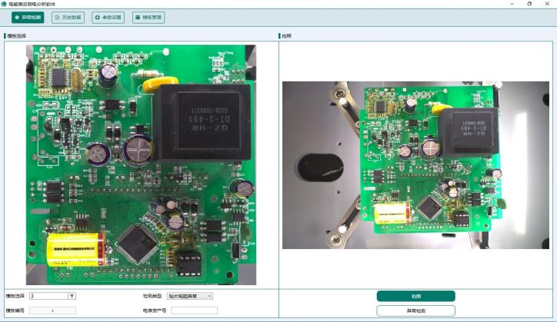

**Figure 11.** Anomaly detection interface

|  |
| --- |
|  |
| **(a)** |
|  |
| **(b)** |

**Figure 12.** Abnormal result analysis interface. **(a)** Resistance anomaly analysis. **(b)** Soldering joint anomaly analysis.

3.1. System Workflow

The operating flow of the meter anomaly detection and analysis system is as follows:

Step1: The equipment is turned on. Turn on the portable meter anomaly detection system and configure. the IP address to connect the HD camera to the tablet.

Step2: Electricity meter RFID information identification. First read the meter information through the RFID data reader, and find the corresponding normal meter circuit board data in the database. If the RFID recognition fails, manually enter the meter template number information.

Step3: Turn on the camera and the light source, place the PCB board of the electric energy meter to be tested in the shooting station, adjust the camera to the appropriate height, and then compare by anomaly detection algorithm after taking the image.

Step4: If the test results are in doubt, the expert shall re-evaluate them with a high-precision multimeter.

3. Conclusion

In order to investigate and deal with the anomaly of the meter replacement components, the theory and technology of image processing and recognition, machine vision, deep learning and so on are adopted in this paper. According to the characteristics and business needs of the on-site work of the power department, the PCB image of the on-site meter is collected, and rapid image feature extraction, image feature registration, point resistance and anomaly judgment and other automated analysis and detection are carried out.

A portable and efficient meter anomaly detection field analysis system has been developed, which improves the efficiency of on-site detection. At the same time, PCB image database of meter has been constructed, which will further promote the development of meter anomaly detection technology.

The system has high detection accuracy, does not require additional mechanical control devices, low cost, easy operation, and ensures that it can be used in the on-site working environment. The experimental results show that the system has good real-time performance, the detection accuracy meets the actual needs, and has practical application value.

References

1. Deng, S.; Research and Development of Defect Detection Technology for Components. Electronic Test **2022**, 31, 35-37.
2. Yang, B.; Analysis and Research on Accurate Anti-Stealing of Electricity. Popular Utilization Of Electricity **2019**, 56, 5-8.
3. Lim, W.; Bonab, M.; Chua, K. An Optimized Lightweight Model for Real-Time Wood Defects Detection based on YOLOv4-Tiny. IEEE International Conference on Automatic Control and Intelligent Systems(I2CACIS), Shah Alam, Malaysia, 25 June 2022, pp. 186-191.
4. Li, Y.; Guo, J. A VGG-16 Based Faster RCNN Model for PCB Error Inspection in Industrial AOI Applications. IEEE International Conference on Consumer Electronics-Taiwan(ICCE-TW), Taichung, Taiwan, 30 August 2018, 1-2.
5. Gabriel, R.; Matthes, J.; Keller H.; Hagenmeyer, V. Detection and Localization of Manipulated Smart Meters Using Super State Hidden Markov Models. IEEE International Conference on Communications, Control, and Computing Technologies for Smart Grids (SmartGridComm), Beijing, China, 25 November 2019, pp. 1-7.
6. Yang, J.; Li, S.; Wang, Z.; Yang, G. Real-Time Tiny Part Defect Detection System in Manufacturing Using Deep Learning. IEEE Access 2019, 7, 89278-89291.
7. Wang, W.; Chen, S.; Chen, L.; Chang, W. A Machine Vision Based Automatic Optical Inspection System for Measuring Drilling Quality of Printed Circuit Boards. IEEE Access **2017**, 5, 10817-10833
8. Sun, J.; Li, Chao.; Wu, X.; Palade, V.; Fang, W. An Effective Method of Weld Defect Detection and Classification Based on Machine Vision. IEEE Transactions on Industrial Informatics, 30 January **2019**, 15, 6322-6333
9. Kuo, C.; Tsai, C.; Wang, W.; Wu, H. Automatic marking point positioning of printed circuit boards based on template matching technique. Journal of Intelligent Manufacturing **2016**, 30, 671-685.
10. Wang D.; Wang L.; Peng D.; Qi, E. Research on Appearance Defect Detection of Power Equipment Based on Improved Faster-RCNN. International Conference on Power and Renewable Energy(ICPRE), Shanghai, China, 15 December 2021, 290-295.
11. Zhao, L.;Wu, Y. Research progress of surface defect detection methods based on machine vision. Chinese Journal of Scientific Instrument **2022**, 43, 198-219.
12. Pan, Z.; Mishra, P. A Survey on Hardware Vulnerability Analysis Using Machine Learning. IEEE Access **2022**, 10, 49508-49527.
13. Andrianova, E.G.; Demidova, L.A. An Approach to Image Matching Based on SIFT and ORB Algorithms; Proceedings - 2021 3rd International Conference on Control Systems, Mathematical Modeling, Automation and Energy Efficiency, Lipetsk, Russia, Summa 2021; pp. 534-539.
14. Yan, C.; Hao, Y.; Zhang, D.; Chen, J. Sequence image matching using adaptive SIFT under complex environmental conditions; 11th International Conference on Digital Image Processing, Guangzhou, China, 11-13 May 2019.
15. Kim, D. Matching points filtering applied panorama image processing using the SURF and RANSAC algorithm. International Journal of Multimedia and Ubiquitous Engineering **2016**, 11, 265-284.
16. Ma, N.; Zhang, X.; Zheng, H.; Sun, J. Shufflenet v2: Practical guidelines for efficient cnn architecture design. Proceedings of the European conference on computer vision **2018**, 11218, 122-138.
17. Chang, Y.; Wei, C.; Chen, J.; Hsieh, P. An Implementation of Health Prediction in SMT Solder Joint via Machine Learning. 2019 IEEE International Conference on Big Data and Smart Computing, Kyoto, Japan, 1 April 2019.
18. Wang, C.; Jiang, B. PCB solder joint defects detection and classification using machine vision. International Journal of Industrial Engineering: Theory Applications and Practice, **2001**, 359-369, 113422.